Q) How do multiple clients connect simultaneously to one port, say 80, on a server?

First remember below two rules:
1. Primary key of a socket: A socket is identified by {SRC-IP, SRC-PORT, DEST-IP, DEST-PORT, PROTOCOL} not by {SRC-IP, SRC-PORT, DEST-IP, DEST-PORT} - Protocol is an important part of a socket's definition.
2. OS Process & Socket mapping: A process can be associated with (can open/can listen to) multiple sockets which might be obvious to many readers but also remember that two processes CANNOT share same socket.

Example: Two clients connecting to same server port means: socket1 {SRC-A, 100, DEST-X,80, TCP}and socket2{SRC-B, 100, DEST-X,80, TCP}. This means host A connects to server X's port 80 and another host B also connects to same server X to the same port 80. Now how server handles these two sockets decides if a server is single threaded or multiple threaded, what is important that one server can listen to multiple sockets simultaneously.
https://stackoverflow.com/questions/3329641/how-do-multiple-clients-connect-simultaneously-to-one-port-say-80-on-a-server

Q) How a server knows which socket to answer?
First understand that for a single server process that is listening to same port, there could be more than one sockets (may be from same client or from different clients). Now as long as a server knows which request is associated with which socket, it can always respond to appropriate client using the same socket. Thus a server never needs to open another port in its own node than the original one on which client initially tried to bind. If any server allocates different server-ports after a socket is bound, then in my opinion the server is wasting its resource and it must be needing the client to bind again to the new port assigned.
https://unix.stackexchange.com/questions/75011/how-does-the-server-find-out-what-client-port-to-send-to

Q) How virtual host works?
https://stackoverflow.com/questions/44751289/does-virtual-host-root-directory-get-picked-after-accept-call

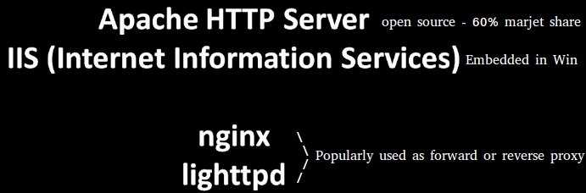

What is forward proxy?
A forward proxy can be used as a central tool in your infrastructure to access the web and it may be combined with a cache to lower your overall bandwidth usage. Forward proxies act as a gatekeeper between client browsers on your local network and all (or some, at your configuration’s discretion) web sites accessed by those clients. The forward proxy will receive the HTTP requests, perform any filtering or request alteration rules you establish, and when appropriate forward the request on to its destination website. The response will return through your proxy, where it may optionally be cached and/or modified, and then returned to the original client.
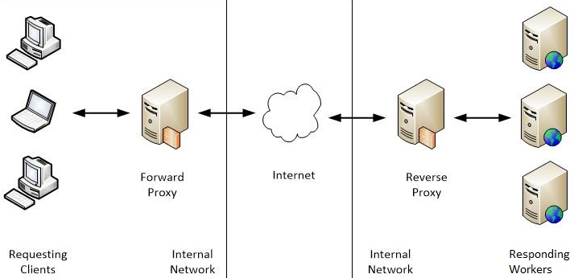

What is reverse proxy?
Reverse proxy is immediately positioned in the network where Responding workers are hosted.
Uses of reverse proxies:
- Reverse proxies can hide the existence and characteristics of an origin server or servers.
- Application firewall features can protect against common web-based attacks, like DoS or DDoS. Without a reverse proxy, removing malware or initiating takedowns, for example, can become difficult.
- In the case of secure websites, a web server may not perform SSL encryption itself, but instead offloads the task to a reverse proxy that may be equipped with SSL acceleration hardware. (See SSL termination proxy.)
- A reverse proxy can distribute the load from incoming requests to several servers, with each server serving its own application area. In the case of reverse proxying in the neighborhood of web servers, the reverse proxy may have to rewrite the URL in each incoming request in order to match the relevant internal location of the requested resource.
- A reverse proxy can reduce load on its origin servers by caching static content, as well as dynamic content - synonym: web acceleration. Proxy caches of this sort can often satisfy a considerable number of website requests, greatly reducing the load on the origin server(s).
- A reverse proxy can optimize content by compressing it in order to speed up loading times.
- In a technique named "spoon-feed" a dynamically generated page can be produced all at once and served to the reverse-proxy, which can then return it to the client a little bit at a time. The program that generates the page need not remain open, thus releasing server resources during the possibly extended time the client requires to complete the transfer.
- Reverse proxies can operate wherever multiple web-servers must be accessible via a single public IP address. The web servers listen on different ports in the same machine, with the same local IP address or, possibly, on different machines and different local IP addresses altogether. The reverse proxy analyzes each incoming request and delivers it to the right server within the local area network.
- Reverse proxies can perform A/B testing and multivariate testing without placing JavaScript tags or code into pages.
- Commercial or enterprise level out-of-box solutions exist and can have an agent installed on user systems to ensure a constant connection to a cloud proxy / reverse proxy server also a SaaS solution. An example of this is McAfee Web Protection Gateway - SaaS solution.
- A reverse proxy can add basic HTTP access authentication to a web server that does not have any authentication.

Evolution of Webserver
Simple setup of web server,

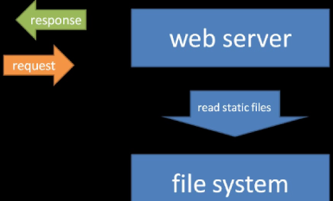

where webserver is configured to access specific directory to access and generate response.

But these days, almost all webservers are configured to accept incoming requests and pass it along to script, that script generates the response and hands back to webserver(as shown below):

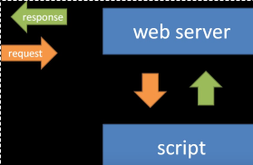

To facilitate this pattern, a standard was developed specifying how a script and webserver should communicate. This standard is called CGI.

Fast CGI

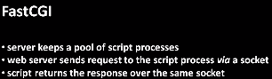

Being on these lines, most commonly used approach, is to take the interpreter(say python) and embed within web server, to execute scripts. For example, mod_python is an Apache module that embeds the Python interpreter within the server. So, mod_python is actually several things:

1) a loadable Apache module(C) which embeds the Python interpreter ( libpython ), thereby providing the ability to execute Python code in-process by Apache.
2) a handler of Apache's request processing phases, allowing for any phase of the request to be implemented in Python.

Recent frameworks such as Ruby on Rails, Catalyst, Django, Kepler and Plack allow use with either the embedded interpreters (mod_ruby, mod_perl, mod_python or mod_lua, for example), or FastCGI.

WSGI(Web Server Gateway Interface)
https://www.python.org/dev/peps/pep-0333/

The Web Server Gateway Interface (WSGI) is a specification for simple and universal interface between web servers and web applications or frameworks for the Python programming language. It was originally specified in PEP 333 authored by Phillip J. Eby, and published on 7 December 2003. It has since been adopted as a standard for Python web application development.

mod_wsgi is an Apache HTTP Server module by Graham Dumpleton that provides a WSGI compliant interface for hosting Python based web applications under Apache. As of version 4.5.3, mod_wsgi supports Python 2 and 3 (starting from 2.6 and 3.2).
It is an alternative to mod_python, CGI, and FastCGI solutions for Python-web integration. It was first available in 2007.
https://en.wikipedia.org/wiki/Mod_wsgi

